**How to create users and groups in Linux**

* Creating users
* Creating groups
* Adding users to groups
* What is passwd/groups?

Let's dive in, so you can up your Linux admin game.

**Creating users**

For this, we will be making use of the **useradd command**. This command is pretty flexible and allows you to create users that can login or even users that cannot login (in the case of creating a user for a software installation).

The basic syntax of the command is:

* **useradd [options] username**

Say, you want to create the user **olivia** such that she has a home directory and can log in. If you were to issue the command:

* **sudo useradd olivia**

**The user would be added, without a home directory and be locked out of logging** in. Instead of issuing the command without arguments, let's go with this:

* **sudo useradd -m olivia**

**The above command would create the user and also create the user's home directory to match the username**. So if you looked in the ***/home* directory, you would now see *olivia***.

But what about that lockout issue? There are two ways you can do this. If you've already created the user, you could issue the command:

* **sudo passwd olivia**

You will be prompted to enter and verify the new password. At this point, the user account will be unlocked and they can login.

If you want to do this all in a single step, that command would look like this:

* **sudo useradd -m olivia -p PASSWORD**

Where PASSWORD is the password you want to use for the user olivia.

Once the user logs in, they **can change their password by using the passwd command**, entering their current password, and then entering/verifying their new password.

If you need to create a user that has no home directory and is locked out from logging in, you can do this with the following commands:

* **sudo useradd -M USERNAME**
* **​sudo usermod -L USERNAME**

Where USERNAME is the name of the user to add.

The first command creates the user without a home directory and the second command locks the user out of logging in.

**Creating groups and adding users**

Now it's time to create a group. Let's create the group editorial. To do this, you would issue the command:

* **sudo groupadd editorial**

Now we want to add our new user, olivia, to the group editorial. For this we will take advantage of the *usermod* command. This command is quite simple to use.

* **sudo usermod -a -G editorial olivia**

The *-a* option tells *usermod* we are appending and the *-G* option tells *usermod* we are appending to the group name that follows the option.

**How do you know which users are already a member of a group? You can do this the old-fashioned way like so:**

**grep editorial /etc/group**

The above command will list pertinent information about the group (**Figure A**).

**Figure A**

Figure A

Using grep to find out who is in a group.

Another method for finding out who is in a group is with the command members. This command isn't installed on most distributions, but can be installed from the standard repositories. If you're using a Ubuntu distribution, the command for installation would be:

* **sudo apt-get install members**

Once installed, the command for listing out who is in our editorial group would be:

* **members editorial**

That's much more efficient than using grep and will only display the member names for the group (**Figure B**).

**Figure B**

Figure B

Using members to find out who is in a group.

### What is passwd/groups?

I want to introduce two files that we will be using as examples. **In the /etc directory, the passwd & the group files hold all of the users and group information.** These files are essential when logging on to the system. Anytime you add a user, that user is added to the passwd file. Let's take a look at **/etc/passwd** first.

When you add a user to the system, that user is placed into the **passwd** file.

Issue command: **less /etc/passwd**

Use the arrows keys to go up and down and “q” to exit.

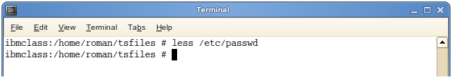

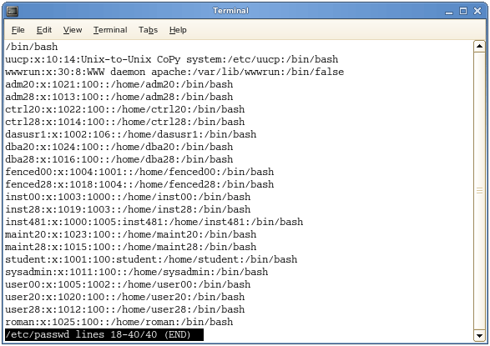

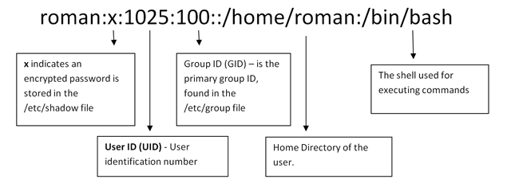

You can edit the file directly or use the commands we will go over shortly. I recommend using the commands especially if you are a beginner. You do not want to corrupt the **passwd** file.

Let's take a look at the group file:

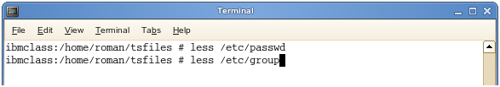

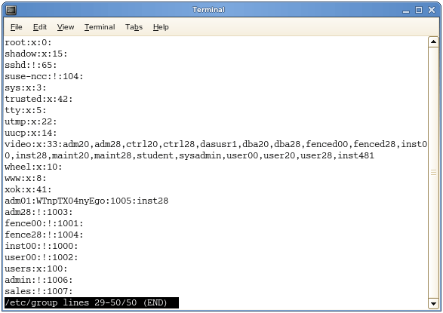

The **/etc/group** file holds all of the group information as well as the users belonging to each group. The structure is very similar to that of **/etc/password**.

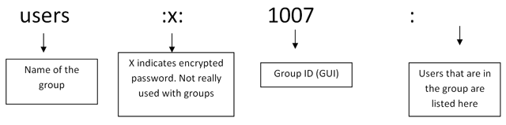

Again, these files are vital to the system and you will need to know them if you are taking any Linux exams.

### Adding/Deleting Users

Adding a user is easy. The command used is: useradd “name of the user”

Note – You must be logged-in as **root** to add, delete, and modify users. It is not recommended to stay logged-in as **root** other than when necessary and only certain members should have root access.

Example:

**useradd roman**

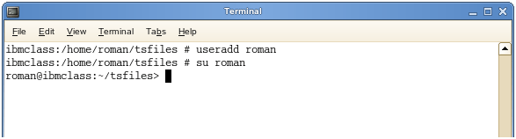

You can then use “su” plus the name of the user you just added to logon. “exit” will take you out.

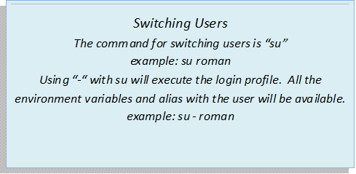

The command for deleting a user is “userdel”.

**userdel roman**

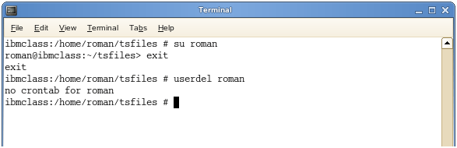

These commands are very basic, but there are other options we have as well. Options:

* **-d** sets home directory for the user (if other than the default which is: /home/”user's name”)
* **-m** creates the home directory

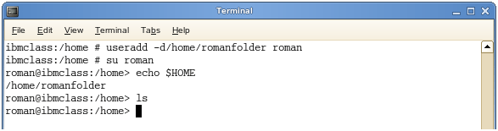

Using the **–d** option on its own will only set the home directory for the user, but does not create it.

You can see I confirm this by “echo $HOME” which tells me my home directory and I use “ls” to confirm.

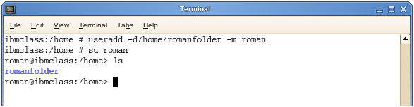

Adding the **–m** option will create the directory.

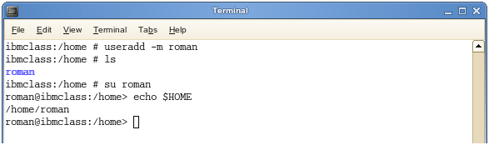

If you just add the user, default directory is **/home/”users name”** and you can just use the **–m** to create.

Lastly, using the “-r” option along with **userdel** will delete the user as well as the home directory.

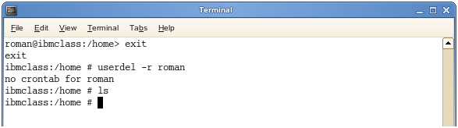

### Changing Passwords

If you are logged in as root, the command is “username” password.

Example: **passwd roman**

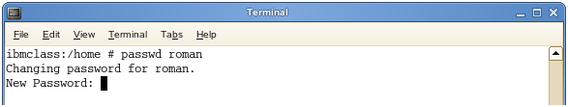

If you are logged on as the user, the command is “passwd”.

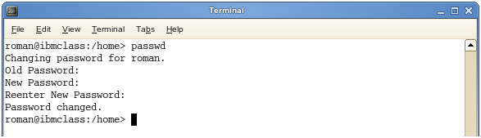

### Adding Users to Groups

Let's say we want to add **roman** to the group **accounting**. “-g” is used to change the user's primary group.

Command is: **useradd –g accounting roman**

I then ran the **grep** command to confirm.

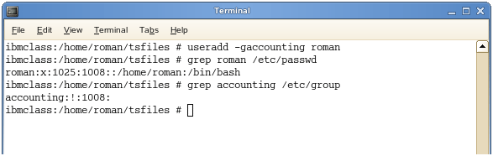

However, say I want to add **roman** to the group **accounting** and make his primary group **sales**. We can add the “-G" option (other groups).

“-G” basically says add this user to a new group, but keep them in the old one (append).

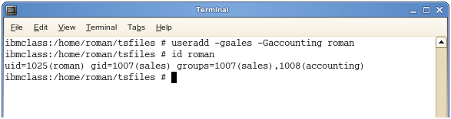

Then issue command “id roman” – to confirm.

We can use “-G” on its own to add a user to another group.

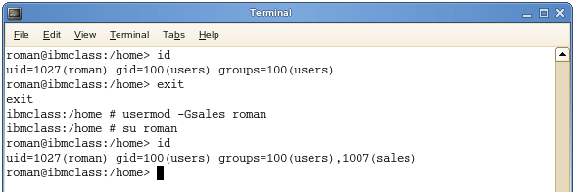

Note: The groups must exit before we can add users to them.

### Modifying Users

If a user is created and you just want to add that user to a group, or change the home directory, etc:

Example: **usermod –G management roman**

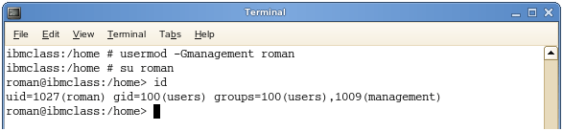

Or you can change the home directory for the user:

Example: **usermod –d/home/newfolder roman**

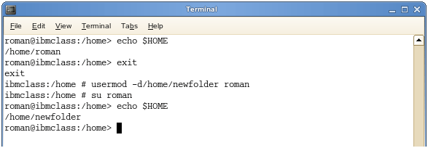

### Creating Groups

The command for adding groups is “groupadd” or “groupdel”.

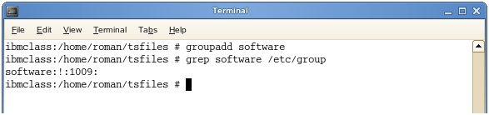

You can confirm by checking the **/group/etc** file.

Example: g**rep software /etc/group** or **cat /etc/group**

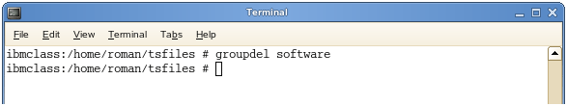

The “groupdel” command will remove the group entirely.

There are a number of options you have when creating users and groups. Again, you could just go into **/etc/passwd** directly and add a user there, but unless you are familiar with file editors and putting a lock on, you should work with the commands. We will go over alternate methods in the Vi section.

### Summary

* **Commands**: useradd, userdel, usermod, groupadd, groupdel
* **Options**

**-d** change user's home directory

**-m** create directory

**-s** used to change the default shell

**-r** remove home directory when deleting user

* "Passwd" will change the user's password